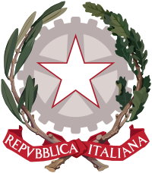

COSA NOSTRA JOINT CRISIS COMMITTEE

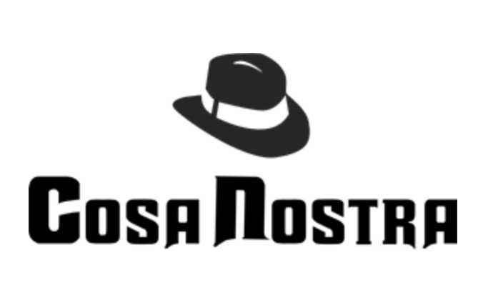

DAIS

Chairperson: Siddharth Gulati
Director: Advait Joshi
Director: Suhail Sohi
Rapporteur: Aaryan Sharma

Background Guide

In this JCC, we simulate one of the greatest conflicts of all time- The Sicilian Mafia versus the Italian government. The committee is divided into 2 factions- members of the Corleonesi and the government. Both blocs will work simultaneously to reach their goal of eliminating the other and reign supreme. The Italian Government must aim to eliminate the Mafia in order to maintain peace as well as instil a sense of peace and security amongst the citizens. Delegates are free to use their imagination and creativity to the fullest to out-think and outplay the other bloc. Teamwork and unity among members of the bloc is of utmost importance here. The next few years in Italy will be marred by conflict, betrayal, and conflict, so all delegates must be prepared to deal with the chaos that will ensue. It must be remembered that anyone found betraying the clan is as good as dead, but only if he is caught…

GOVERNMENT RETALIATION OF LA MATTANZA ELIMINATING CORLEONESI MAFIA CLAN RIVALS AGAINST THE ITALIAN STATE.

FREEZE DATE: 16th March, 1978

Cosa Nostra

The Cosa Nostra is an Italian Mafia-terrorist-type organized crime syndicate and criminal society originating in the region of Sicily and dating to at least the 19th century. The Mafia's core activities are protection racketeering, the arbitration of disputes between criminals, and the organizing and oversight of illegal agreements and transactions. The Mafia has been described as an "industry of violence", a cartel of private protection firms. The mafia's principal activities are settling disputes among other criminals, protecting them against each other's cheating, and organizing and overseeing illicit agreements, often involving many agents, such as illicit cartel agreements in otherwise legal industries. It only serves specific clients rather than the general public. This cartel claims the exclusive right to sell extra-legal protection services within their territories, and by their labels (man of honour, mafioso, etc.), they distinguish themselves from common criminals whom they exclude from the protection market. A clan is typically led by a "boss" who is aided by an underboss and supervised by one or more advisers. Under his command are groups of about ten "soldiers".

The 10 Commandments of the Cosa Nostra are –
1. No one can present himself directly to another of our friends. There must be a third person to do it.
2. Never look at the wives of friends.
3. Never be seen with cops.
4. Don't go to pubs and clubs.
5. Always being available for Cosa Nostra is a duty - even if your wife is about to give birth.
6. Appointments must absolutely be respected. (refers to rank and authority.)[164]
7. Wives must be treated with respect.
8. When asked for any information, the answer must be the truth.
9. Money cannot be appropriated if it belongs to others or to other families.
10. People who can't be part of Cosa Nostra: anyone who has a close relative in the police, anyone with a two-timing relative in the family, anyone who behaves badly and doesn't hold to moral values.

Some other functions of the Mafia are to buy votes for their politician clients. They provide protection and invest capital in smuggling gangs. People rarely trust their money to criminal gangs. The Mafia are the ones who raise the money needed from investors to ensure all parties act in good faith. They are loan sharks collecting around €1.4 billion a year. The Sicilian Mafia in Italy is believed to have a turnover of €6.5 billion through control of public and private contracts. They used threats of violence and vandalism to muscle out competitors and win contracts for the companies that they control.
Certain types of crimes are forbidden by Cosa Nostra, either by members or freelance criminals within their domains. They are generally forbidden from committing theft. Kidnapping is also generally forbidden, even by non-mafiosi, as it attracts a great deal of public hostility and police attention. These rules have been violated from time to time, both with and without the permission of senior mafiosi.
This bloc of the committee will aim to maximize the influence of the Cosa Nostra over the Italian Government. Their goal is to overcome the attempts at suppression by the Italian police.

The Italian Government

The Italian Government set out to fight against the mafia-related organized crime in Italy. It aims at ensuring the proceeding, in a coordinated form, of the preventive investigation activities regarding the organized crime, and to carry out judiciary police investigations related exclusively to crimes attributable to like-mafia associations. It performs investigations of judiciary police related to crimes of mafia-type association and it ensures the progress of preventive investigation activities regarding organized crime.

The government formed many pools and bodies in order to try and suppress the influence of the Cosa Nostra. This included the Antimafia Commission which is a bicameral commission of the Italian Parliament, composed of members from the Chamber of Deputies and the Senate. There was also the Antimafia Pool, which was a group of investigating magistrates at the Prosecuting Office of Palermo who closely worked together sharing information and developing new investigative and prosecutorial strategies against the Sicilian Mafia. As well as these, there is the Direzione Investigativa Antimafia, also known as DIA, an Italian multi-force investigation body under the Department of Public Security of the Ministry of the Interior.

As the influence of the Cosa Nostra in Italy rises, this bloc must try its best to suppress it and keep it under control.

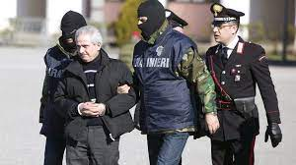

Timeline

Timeline leading up to the Freeze Date( 1943 - 1978):
- 1943- Luciano Leggio drafted by Michele Navarra, Corleone capo, in the services of the mafia. Being born in an extremely poor family, Leggio turned to crime in his teens before getting recruited by Navarra as a hitman.
- March, 1948 - Trade Unionist Placido Rizzotto shot by Leggio. Rizotto, an Italian partisan, socialist, peasant and trade union leader was kidnapped and murdered while performing activist work with farm laborers, trying to help them take over unfarmed land on large estates in the area.
- August, 1958 - Navarra shot dead by Leggio and his men. Being next in line to lead the Cosa Nostra, Leggio carried out a series of murders including Navarra and few of his friends. Thus, Leggio became the leader of the Corleone Mafia.
- September, 1958 -First Center-Left Government of the Sicilian Region Assembly.
- 1962 - First Mafia War between Salvatore Greco and Angelo La Barberabegins. Fueled by the murder of Calcedonia de Pisa by the La Barbaras set the stage for the first mafia war of its kind. Find a few links attached to the topic below.
- 1962- Assembly votes in favor of setting up a commission of inquiry into the mafia.
- June 1963 - Ciaculli Car Bombing ends the First Mafia War.
- 1963 - Sicilian Mafia Commission dissolves itself; families fiee or go into hiding.
- 1965 - Law 575 of Italian Penal Code passed.
- 1967 - A wave of Student protests, strikes and demonstrations as a part of the “Strategy of Tension”, begins.The purpose is to create a general feeling of insecurity in the population and make people seek security in a strong government.
- 1968- 117 combatants of the first mafia war sent to trial in Catanzaro, Calabria. Most acquitted, Angelo La Barbera and Salvatore Greco get 22.5 and 10 years respectively.
- 1969 - Leggio acquitted at the trial in Bari
- December, 1969 - Explosion in Milan bank, culprits linked to neo-fascists and Italian secret services. This was popularly known as the Piazza Fontana Bombing whicch occurred on 12 December 1969 when a occurred on 12 December 1969 when a bomb exploded at the headquarters of Banca Nazionale dell'Agricoltura (the National Agricultural Bank) in Piazza Fontana (near the Duomo) in Milan, Italy, killing 17 people and wounding 88.
- 1970 - Sicilian Mafia Commission revived, with Leggio, Stefano Bontate and Gaetano Badalamenti at the head; it became officially operative in 1974.
- December 1970 - A neo-Fascist prince’s failed attempt to trigger a coup d’état. This was popularly known as the Golpe Borghese.
- 1971 - Son of Francesco Vassallo, construction magnate and close to Badalamenti and Bontate, kidnapped by Leggio’s men.
- December 1974-Luciano Leggio arrested and imprisoned for life; Salvatore Riina becomes the effective head of Corleonesi Family. This forms a very important mark in the history of the Cosa Nostra as the New Head is elected as the head of Corleonesi.
- 1975 - Riina kidnaps and kills Nino Salvo’s father-in-law. Riina intended to cut out all potential threats to his position which indicated the position of his clan at the apex of the Sicilian Mafia families.
- 1977- Corleonesi expel Gaetano Badalamenti from Cosa Nostra. This was done due to the opposition he showed towards drugs.
- March, 1978 - Former Prime Minister Aldo Moro kidnapped by militant communists was killed. The country seems to move into a state of disturbance and hostility as the people feel scared under the staggering influence of the Mafiosis. —--FREEZE DATE

Matrix
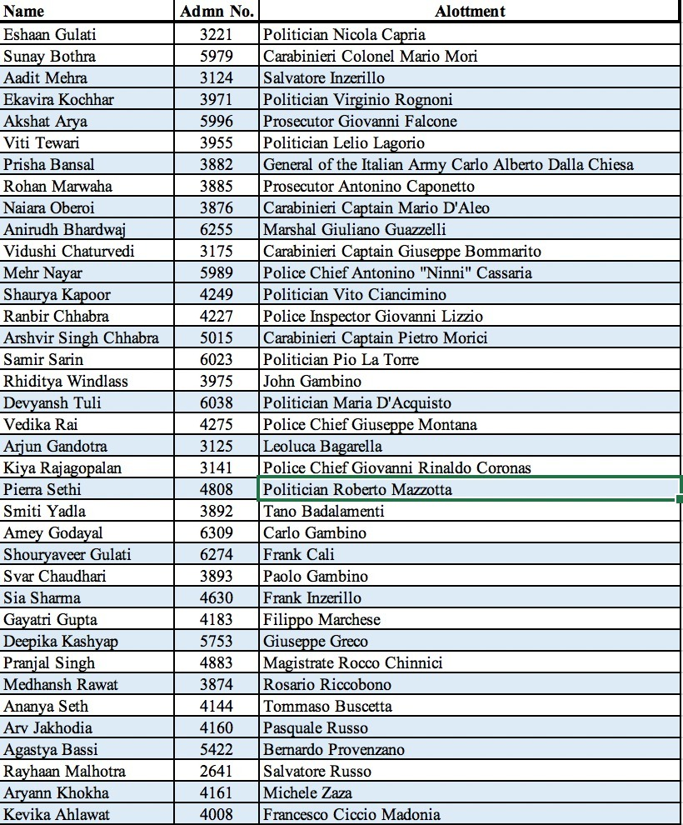

Allotments introduction

Nicola Capria was an Italian politician, member of the Italian Socialist Party. He was Deputy from 1976 to 1994 and served also as Minister several times from 1986 to 1992 He was also city councilor in Messina, Vice-president of the Sicily Region, regional deputy to the Sicilian Regional Assembly and regional secretary of the Sicilian PSI.

Carabinieri Colonel Mario Mori is an Italian general and prefect . He was commander of ROS and director of SISDE .

Inzerillo Brothers( Salvatore and Frank)- Salvatore was an Italian member of the Sicilian Mafia, also known as Totuccio. He rose to be a powerful boss of Palermo's Passo di Rigano family. His brother Frank worked closely with him for many years.

Virginio Rognoni is an Italian politician , lawyer and academic. An anti fascist, he worked in the Interior Ministry from 1978 to 1983.

Giovanni Falcone was an Italian judge and prosecuting magistrate. From his office in the Palace of Justice in Palermo, Sicily, he spent most of his professional life trying to overthrow the power of the Sicilian Mafia.

Lelio Lagorio was an Italian politician who served as the first President of Tuscany from 1970 until 1978. He was the first PSI politicians to become Minister of Defence in Italy (1980–1983).
Carlo Alberto dalla Chiesa was an Italian general, notable for campaigning against terrorism during the Years of Lead.

Antonino Caponnetto was an Italian Antimafia magistrate.

Mario D'Aleo was an officer of the Arma dei Carabinieri. Captain of the carabinieri , he became commander of the Company of Monreale in 1980 taking the place of Emanuele Basile, killed in a mafia ambush

Giuliano Guazzelli was an Italian soldier belonging to the Arma dei Carabinieri.

Giuseppe Bommarito was an Italian carabiniere

Antonino Cassarà , known as Ninni was an Italian policeman he was Commissioner of the State Police at the Reggio Calabria police headquarters and then in Trapani , where he met Giovanni Falcone . He was then deputy deputy commissioner in force at the Palermo police headquarters and the deputy manager of the mobile team.

Vito Ciancimino was an Italian politician, and the mayor of Palermo from 1970 to 1971 but resigned from the post in 1971.

Giovanni Lizzio was an Italian policeman In his many years of service, he investigated extensively both on the traditional mafia gangs and on the emerging ones,becoming, by virtue of his vast knowledge on the subject, a sort of living archive for the entire police headquarters, as well as one of the best known policemen in the city of Etna thanks to the many arrests of mafia members.

Pietro Morici was an Italian carabiniere.

Pio La Torre was a leader of the Italian Communist Party. He initiated a law that introduced a new crime in the Italian legal system, mafia conspiracy, and the possibility for the courts to seize and to confiscate the assets of the persons belonging to the mafia conspiracy.

Giovanni "John" Gambino was an Italian-born American mobster. Born in Palermo, Sicily, he became a made member of the Gambino crime family in 1975 and a capodecina or captain, and head of the crime family's Sicilian faction, appointed by family boss John Gotti in 1986
Maria D'Acquisto was an Italian politician.

Giuseppe Montana, was an Italian policeman. Commissioner of the Judicial police of Palermo, he was chief of the new created Sezione Catturandi, which was responsible for the search of fugitives.
Leolucca Bagarella: Was a member of the Sicilian Mafia from the town of Corleone. Bagarella sided with Lucciano Legio of the Corleonesi in the late 1950s. Bagarella was the brother-in-law of Salvatore Riina.

Giovanni Rinaldo Coronas: His career started from the Turin Police Headquarters, but in 1943 Coronas passed to the Civil Administration of the Interior. He carried out the duties of head of cabinet at the prefectures of Nuoro and Forli. He was deputy police chief until 1974. On 19 January 1979 he was appointed Chief of Police. (For this committee we are assuming he was appointed Chief before the freeze date)

Roberto Mazzotta: Mazzotta became a member of the DC(Christian Democracy) from a young age. He was the DC's regional secretary of Lombardy and deputy national secretary. Mazzotta served as the undersecretary of state in 1974. He was appointed minister of regional affairs to the cabinet led by Prime Minister Forlani later on.

Tano Badalamenti: Was one of the most powerful and influential members of the Sicilian Mafia. He was the capofamiglia( crime boss )of his hometown Cinisi, and headed the Sicilian Mafia Commission in the 1970s. He was one of the primary suspects in the murder of political activist Peppino Impastato in 1978.

Carlo Gambino: The capofamiglia of the Gambino crime family. After the Apalachin Meeting in 1957, and the imprisonment of Vito Genovese in 1959, Gambino took over the Commission of the American Mafia. (Although Carlo Gambino died in 1976, for this committee we are ignoring the event of his death and assuming that he is still alive)

Frank Cali: Was the eventual acting boss of the Gambino Crime family. Law enforcement considered Cali to have been the Gambinos' "ambassador to Sicilian Mobsters " and had linked him to the Inzerillo Mafia Family from Palermo.

Filippo Marchese: Was a leading figure in the Sicilian Mafia and a hitman suspected of dozens of homicides Marchese was one of the most feared killers working for mafia boss Vincenzo Chiaracane
He was the boss of the Mafia family in the Corso dei Mille neighbourhood in Palermo.

Giuseppe Greco: Was a hitman and high-ranking member of the Sicilian Mafia, and one of the most prolific killers in criminal history. He was affiliated to the Ciaculli mafia family.

Rocco Chinnici: Was an aniti-Mafia magistrate, who was instrumental in reviving investigations into the Mafia and understood the need to bridge the gap between the judiciary and the rest of Sicilian society to create a counterculture against the Mafia

Rosario Riccobono: He was the boss of Partanna Mondello. In 1974 he became a member of the Sicilian Mafia Commission. During the 1970s Riccobono was one of the most influential members of the Commission, and the Cosa Nostra's king of the drug trafficking.

Tommaso Buscetta: Was an Italian mobster and a member of the Sicilian Mafia He became one of the first of its members to turn informant (someone who provides agencies with inside information) and explain the inner workings of the organization.

Pasquale Russo: and boss of the Russo Clan from Nola which he co-founded. He runst he the clan together with his brother Salvatore.

Bernardo Provenzano: was an Italian mobster and chief of the Sicilian Mafia clan known as the Corleonesi a Mafia faction that originated in the town of Corleone, and de facto the boss of bosses.
Provenzano was part of the Corleonesi Mafia Clan who backed mob boss Luciano Leggio in the ambush and murder of Michele Navarra in the late 1950s.

Salvatore Russo: An Italian Camorrista and boss of the Russo Clan from Nola, which he co-founded. The criminal career of the Russo brothers started in the 1970s and they had close ties to Michele Zaza.

Michele Zaza: was a member of the Camorra criminal organisation who was also initiated in the Sicilian Mafia. He headed the Zaza clan in Naples. Zaza was known as ’O Pazzo ‘(the madman) due to his outspoken and implausible public statements.

Francesco Madonia: was the boss of the San Lorenzo-Pallavicino area in Palermo. In 1978 he became a member of the Sicilian Mafia Commission.
Ciccio Madonia became the unquestioned patriarch of the Resuttana Mafia family, having replaced Antonino Matranga, who was murdered in 1970.

Paolo Gambino: Member of the Gambino Crime Family. Worked closely with and was extremely trusted by Carlo Gambino and other members of the family.

ROP
The rules of procedure have been covered in the other document summarising all the various points, directives and communiques etc, that the delegates are expected to be familiar with.

Few links and references:

- https://en.wikipedia.org/wiki/Sicilian_Mafia#:~:text=The%20Sicilian%20Mafia%2C%20also%20simply,at%20least%20the%2019th%20century.
- https://wearepalermo.com/the-history-of-sicilian-mafia/
- https://www.italyonthisday.com/2017/04/stefano-bontade-mafia-supremo.html
- https://www.kanoplay.com/history-of-mafia-wars
- https://en.wikipedia.org/wiki/Ciaculli_massacre
- https://en.wikipedia.org/wiki/Golpe_Borghese
- https://www.theguardian.com/world/2017/nov/17/toto-riina-sicilian-mafia-boss-of-bosses-dies-cosa-nostra-italy
- https://timenote.info/lv/person/view?id=11563870&l=en

These are just a few articles and websites to get you started with your research. Use articles, YouTube videos, websites and even movies to further strengthen your knowledge regarding the agenda. Work hard, and remember to have fun along the way, for this is the agenda of the Mafiosi!
